Report of | Meeting | Date
Chief Executive  (Introduced by the Leader of the Council) | Council | Wednesday, 26 January 2022

Greater Lancashire Deal
Is this report confidential? | No
Is this decision key? | Not applicable

Purpose of the Report
- To provide Full Council with an update on work undertaken towards development of strengthened joint working, a long term strategic plan and a County Deal for the Lancashire area and seek agreement to progress this work.

Recommendations to Council
- Support the outline "Our New Deal for a Greater Lancashire" at Appendix 1 as the initial draft basis for further discussion and development of a possible County Deal for the Lancashire area;

- Agree the principles of governance as set out in Appendix 2 for any future deal; an

- Agree that the Leader of the Council continues to work with Lancashire Leaders in line with the principles agreed in recommendations 1 & 2 above, and note that any formal proposals will require approval by Full Council at the appropriate time.

Corporate priorities
- The report relates to the following corporate priorities:

An exemplary council | Thriving communities
A fair local economy that works for everyone | Good homes, green spaces, healthy places

Background to the report
- The attached report is being considered by the Full Council of each of the fifteen local authorities in Lancashire, that is, the county council, two unitary authorities and each of the 12 district councils.

- The intention is that this report sets out the general principles and high level priorities of a long term strategic plan and County Deal. As progress is made, more details about specific asks will be developed, and there will be opportunities for all of the partner authorities to contribute to and influence that, including identifying specific schemes and activities.

- Full Council is asked to consider the report and the recommendations set out above

Introduction
- Lancashire has a rich heritage, it is a diverse county which has opportunities for all and is home to globally leading firms and nationally significant assets. Its thriving £34bn economy was growing rapidly prior to the pandemic with the 4th largest aerospace cluster in the world helping achieve significant productivity gains. With a population of 1.5m people, Lancashire's 54,000 businesses generate 749,000 jobs across a range of important and emerging sectors from manufacturing and hospitality to cyber, digital and low carbon. A place of amazing beauty, its natural assets support the economy and workforce as well as providing a thriving tourism destination for visitors and an opportunity to support net zero and cleaner energy ambitions.

- Local government arrangements in Lancashire are complex with a county council, two unitary authorities and 12 district councils. However, over the last two years, the context of a global emergency response has created a platform to empower Leaders of all the 15 local authorities in Lancashire to strengthen relationships and partnerships with wider stakeholders. Whilst the pandemic has generated significant, bespoke impacts in Lancashire that have exacerbated longer-term underlying structural issues and inequalities, Leaders are using this foundation as a basis for recovery and to drive forward economic growth.

- With a robust evidence base and utilising the strong local knowledge of elected representatives, Leaders are developing a vision and ambition for the future of Lancashire looking ahead to 2050 to recover, grow and decarbonise the economy, improving the place and the life opportunities of its people. Their plans to achieve this will not only realise opportunities for Lancashire and UK plc but in doing so, help address many of the structural deficits and level up across the county.

- With the government’s much-anticipated levelling up White Paper on the horizon, the time is right for Lancashire to move forward together with a collective voice to make the case for more powers and investment for all of Lancashire.

- Leaders have identified that the work is now at a stage where it is important to secure the engagement and support of all members. This report is therefore being presented to all fifteen local authorities.

- This report covers:

- Lancashire 2050, which sets out the headline themes which could be included in a long term strategic plan and ambition for Greater Lancashire.

- Our New Deal for a Greater Lancashire, which sets out an initial scope and is a first phase of work that could begin to frame a set of devolution asks as part of a County Deal.

- Governance, which sets out information about the governance options to oversee the long-term plan and deliver the deal, and the principles agreed by Leaders for any governance arrangements.

- It is important to note that the government's anticipated Levelling Up White Paper will influence to a large extent the shape and substance of a County Deal that Lancashire authorities will be able to pursue. The information, advice and proposals in this paper may therefore, need to change to reflect the white paper. This report and recommendations seek to position Lancashire so it is better placed to commence early County Deal discussions with Government.

Developing a Lancashire Plan
- Significant work has taken place across Lancashire to gather evidence that will shape an overarching vision, strategy and plan for the whole of 'Greater Lancashire'. This work has helped inform the scale of ambition and the development of robust key priorities within the scope of what Our New Deal for a Greater Lancashire could look like, together with the governance principles described in this report.

- Once fully developed and adopted, in tandem with a devolution deal, Lancashire's overarching strategic plan will be forward looking and take a long term view, setting the vision and ambition over a 20-30 year period. Approaching this strategic framework in this way will ensure that the scope of Lancashire's devolution proposals addresses both the immediate priorities and longer term ambitions.

- Hence, an overarching strategic plan that looks to Lancashire in 2050, would need to describe a broader ambition beyond the immediate priorities framed by the four themes set out within the scope for Our New Deal for a Greater Lancashire [at Appendix 1]. Developing the strategy and priorities this way also ensures that policy areas overlap to tackle cross cutting opportunities such as skills, health and the environment, avoiding any unintentional policy silos. For example, tackling priorities that are currently included in the devolution scope around early years, housing quality, employment and skills, will also address some of the wider determinants of poor health as part of a longer term ambition for Lancashire, even though health priorities are yet to be agreed and fully set out working with our partners in the NHS through the Lancashire and South Cumbria integrated health and care system.

- As a result, in addition to the four themes identified within Our New Deal for a Greater Lancashire, additional policy areas within the Lancashire 2050 strategic plan could include themes such as health (including inequalities, improvement and wellbeing) and community building (including crime and public safety), see Diagram 1 below. Work to shape and consult on Lancashire 2050 will continue in tandem with work on Our New Deal for a Greater Lancashire over the coming months and report through to Leaders and Councils and ultimately through any new governance arrangements adopted.
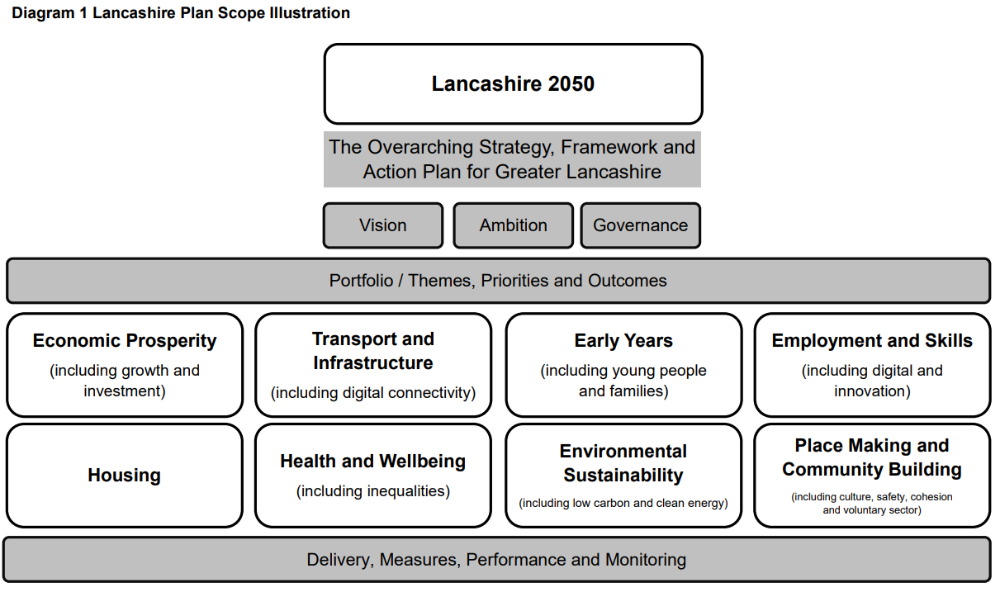

Our New Deal for a Greater Lancashire (Appendix 1)
- With a long term strategic plan in place, our ask of government through a county deal, would be for the devolved powers, flexibilities and funding to accelerate the delivery of the immediate priorities set out in the plan, see Diagram 2 below. Based on the experience of other areas which have secured devolution deals, our ask could be in the order of say £5bn investment into the wider Lancashire area to address local needs and priorities as determined by and in Lancashire over the next 5-10 years. This would be across four core themes of:
- Economic growth and investment
- Transport, connectivity and infrastructure
- Early years, education, adult skills and employment
- Environment, climate change and housing quality

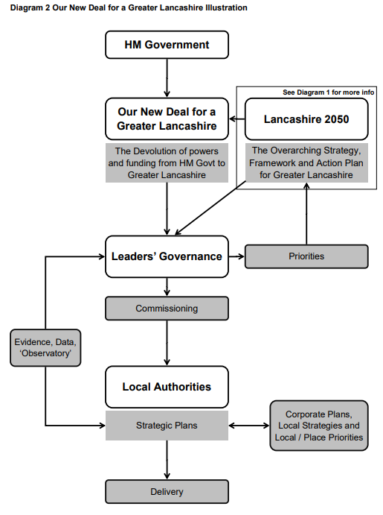

Next Steps
- In order for Lancashire to move forward with a strong collective voice, the engagement and support of all councils will be extremely important. This will give Leaders a mandate to collectively move forward on the issues set out in this report, and to engage with government to develop and deliver a great deal for Lancashire, for presentation back to each Full Council in Lancashire to consider and decide.

Climate change and air quality
- At this time the work noted in this report does not impact the climate change and sustainability.

Equality and diversity
- As this report addressed the delivery of council services there are likely to be Equality Act implications at later stages. At this time however, the report seeks agreement to principles and the continued investigation of the proposal at the attached appendix. There are no direct implications for the Equality Act in this decision, consideration of equality and diversity obligations will form part of the future discussions and members will be advised at that time of the implications.

Risk

At this time the main risk is loss of opportunity should this proposal not be pursued. The benefits of investigating, progressing and ultimately delivering a Greater Lancashire are detailed in the report and appendix. Failure to deliver this will put opportunities for central government devolution of powers at risk.

Comments of the Statutory Finance Officer
- The report sets out the general principles and high level priorities of a long term strategic plan and County Deal for Lancashire and as such, there are no specific financial implications arising from the report, although it is anticipated that with a long term strategic plan in place, the ‘ask’ from government through a county deal, would be for funding to accelerate the delivery of the immediate priorities outlined in the plan. Based on the devolution deals secured in other areas, this could be in the order of around £5bn investment into the wider Lancashire area.

- As progress is made, more details about specific asks will be developed, with opportunities for all of the partner authorities to contribute to and influence these, including identifying specific schemes and activities; any formal proposals, including any associated financial implications for South Ribble BC, would require approval by Full Council at the appropriate time.

Comments of the Monitoring Officer
- Given that decision at this point is to seek agreement to principles for the establishment of Greater Lancashire and for the Leader of the council to continue negotiations and discussions on behalf to the Council, there are no real legal implications. The proposed governance arrangements will require further development but are a sound framework on which to build.

Background documents
There are no background papers to this report.

Appendices
Appendix 1 – Initial Scope
Appendix 2 – Governance
Appendix 3 – Presentation slides

Report Author: | Email: | Telephone: | Date:
Gary Hall (Chief Executive) | gary.hall@southribble.gov.uk | 01772 625625 | 12 January 2022

